**Name: Student ID:**

1. [10 points] Given the following two round-robin processes, find a deadlock state. Derive the resource allocation graph of this state and show that it indeed is a deadlock.

**Process 1 Process 2**

P(S1) P(S2)

. .

. .

. .

P(S2) if *(condition)* {P(S1)

V(S1)}

V(S1) P(S3)

. .

P(S3) V(S2)

V(S3) V(S3)

V(S2)

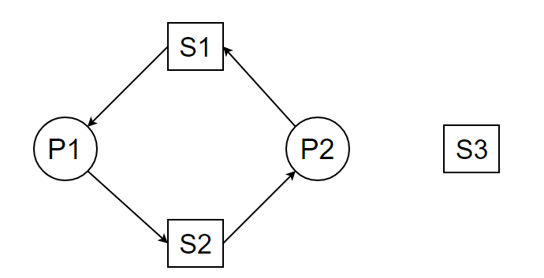If (condition == true) and P1 gets pre-empted after P(S1) and before P(S2), P2 will acquire the lock for S2 and the RAG will be as follows:

1. [10 points] The following task graph shows the dependencies between jobs in a real-time system. The release time and execution time for each job is given in the table below. Job Ji has higher priority than Jk if i<k. Assuming preemptive scheduling, and only one processor in the system, draw the scheduling Gantt chart for this graph. *(Hint: Pay attention to the type of nodes in the graph which shows the type of precedence, i.e. AND or OR, for each job.)*

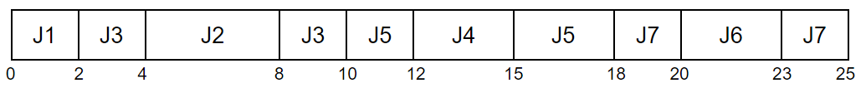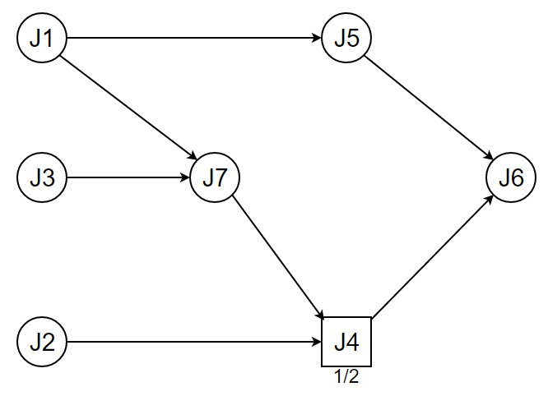

|  |  |  |
| --- | --- | --- |
| **Job ID** | **Release time** | **Execution time** |
| 1 | 0 | 2 |
| 2 | 4 | 4 |
| 3 | 0 | 4 |
| 4 | 12 | 3 |
| 5 | 5 | 5 |
| 6 | 20 | 3 |
| 7 | 0 | 4 |